**Movie Database Report**

Submitted By

<<RIJUSHREE GUHA>> Department of Computer Science

University Roll No. 12019009002167 UEM, Kolkata

<<Rajeev Ranjan Singh>> Department of Computer Science

University Roll No. 12019009022180 UEM, Kolkata

<<Ranit Gosh>> Department of Computer Science

University Roll No. 1201900923121 UEM, Kolkata

**Paper Code:** PCCCS481

**Paper Name:** Object Oriented Programming Using Java

Department of Computer Science

UEM, Kolkata



UNIVERSITY OF ENGINEERING & MANAGEMENT, KOLKATA

University Area, Plot No. III – B/5, New Town, Action Area – III, Kolkata – 700 156

**TABLE OF CONTENTS**

|  |  |
| --- | --- |
| **ABSTRACT** | **PAGE NO** |
|  |  |
| **INTRODUCTION** | **1** |
| **LITERATURE SURVEY** | **3** |
| **PROBLEM STATEMENT & DISCUSSION** | **6** |
| **PROPOSED SOLUTION & RESULT ANALYSIS** | **7** |
| **CONCLUSION & FUTURE SCOPE** | **13** |
| **BIBLIOGRAPHY** | **14** |

**Pg-1**

**CHAPTER – 1:**

**INTRODUCTION**

A database management system (or DBMS) is essentially nothing more than a computerized data-keeping system. Users of the system are given facilities to perform several kinds of operations on such a system for either manipulation of the data in the database or the management of the database structure itself. Database Management Systems (DBMSs) are categorized according to their data structures or types.

 It consists of a group of programs which manipulate the database. The DBMS accepts the request for data from an application and instructs the operating system to provide the specific data. In large systems, a DBMS helps users and other third-party software to store and retrieve data.

DBMS allows users to create their own databases as per their requirement. The term “DBMS” includes the user of the database and other application programs. It provides an interface between the data and the software application.

Here, is the list of some popular DBMS system:

MySQL, Microsoft Access, Oracle, PostgreSQL, FoxPro, SQLite, IBM DB2, LibreOffice Base, MariaDB, Microsoft SQL Server etc.

This project provides a database and GUI for storing and retrieving information about Movies. The console based project only shows the functionality through the switch case statements. The java swing application provides a better GUI. The database is capable of storing many attributes about a movie such as its Title, Year of release, Director, Actors, ratings etc. Since actors and directors can be relevant to many different movies, their information is stored in separate tables and attached to each movie where necessary to avoid storing duplicate information and make it quicker to add actor/director information to a movie. There is also a table of rating related to each movie and the GUI user can create/view reviews on the movie.

**Why use DBMS?**

* DBMS Provides security and removes redundancy
* DBMS has many advantages over tradition Flat File management system
* End-Users, Application Programmers, and Database Administrators are the type of users who access a DBMS
* DMBS is widely used in Banking, Airlines, Telecommunication, Finance and other industries

**Pg-2**

* Four Types of DBMS systems are 1) Hierarchical 2) Network 3) Relational 4) Object-Oriented DBMS
* DBMS serves as an efficient handler to balance the needs of multiple applications using the same data
* Cost of Hardware and Software of a DBMS is quite high which increases the budget of your organization

**JDBC helps developers with the following aspects:**

* It helps to establish a connection with a data source
* It allows to send queries and updates statements
* It helps to fetch the data from the database and process the fetched results.

**Pg-3**

**CHAPTER – 2:**

**LITERATURE SURVEY**

**Abstract:** International Journal of Computer Applications (0975 – 8887) Volume 162 – No 9, March 2017 35 A Literature Review on Evolving Database Shagufta Praveen Research Scholar Computer Science Department Glocal University, Saharanpur India Umesh Chandra, PhD Assistant Professor Computer Science Department Glocal University, Saharanpur India Arif Ali Wani Assistant Professor Computer Science Department Glocal University, Saharanpur India ABSTRACT Since 90's, database has shown tremendous growth. This growth can be determined in different aspects. Different demands of every era give database a new bunch of challenges. To achieve that challenges, researchers come up with different ideas and combinations. These various combinations enhance features of database and this way database starts evolving from one period to another. Database that we had in 1960 is entirely, absolutely different from what we have now. This survey addresses the evolution of database from beginning to today. It also introduces that how different technologies, concepts and theories helped database to evolve, as just one good player in a team is not enough to win the match. The fact is still industries are in hope for something better in context to database technologies.

* 1. **Relational Database** Early in 1960’s, IDS (Integrated data store) was designed by Charles Bachman, which was a network database, it influenced other DBMS for further growth. It was designed to improve performance through available hardware of that time. In 1966, IMS (Information management System) released by IBM, and was based on hierarchical database. It was designed to keep the stock details of very large bills of materials for Saturn V moon rocket and Apollo space. IMS (based on hierarchical data model) was not strictly followed hierarchical. In this model, a child could have two parents.

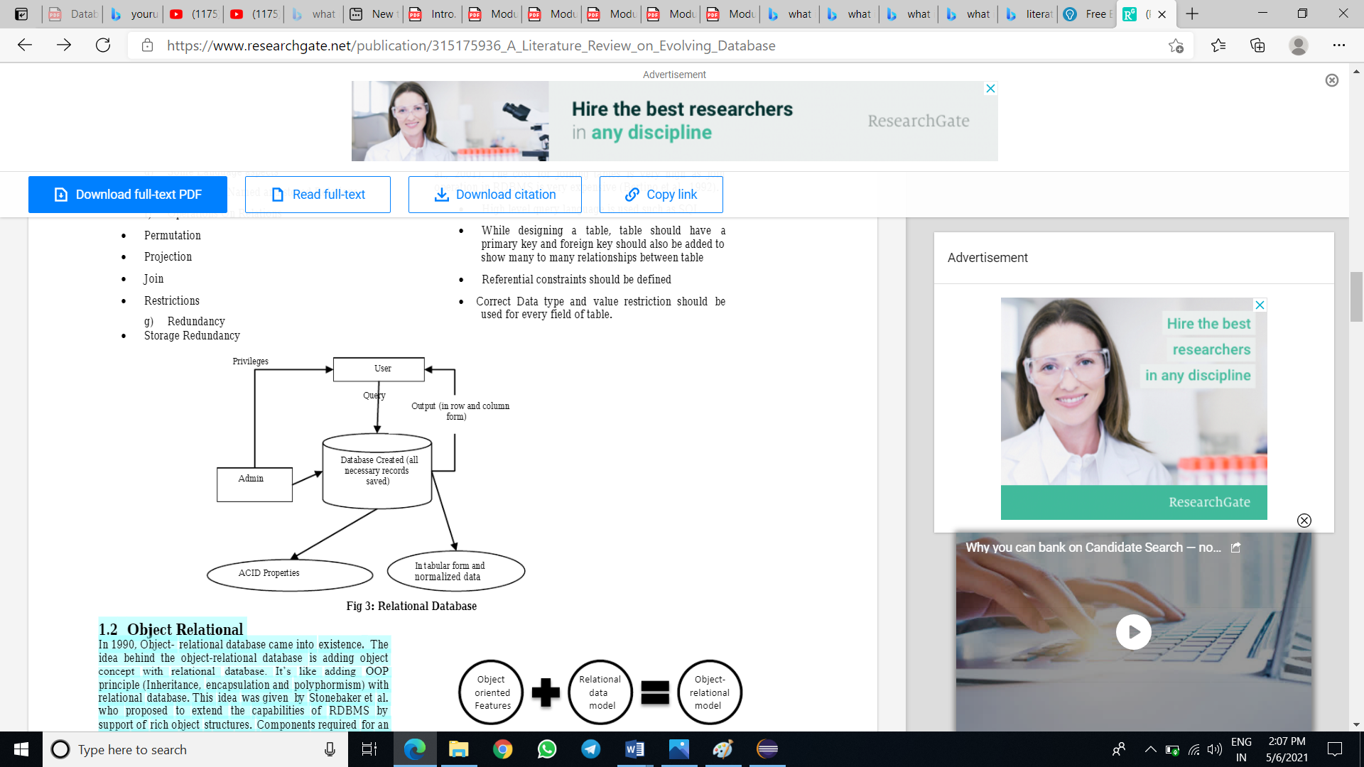

**Pg-4**

* 1. **Object Relational** In 1990, Object- relational database came into existence. The idea behind the object-relational database is adding object concept with relational database. It’s like adding OOP principle (Inheritance, encapsulation and polyphormism) with relational database. This idea was given by Stonebaker et al. who proposed to extend the capabilities of RDBMS by support of rich object structures. Components required for an object relational model are: Data structures (object table for storage), Integrity constraints(object identifier, relationship), Operations (query language)(Codd, 1970).

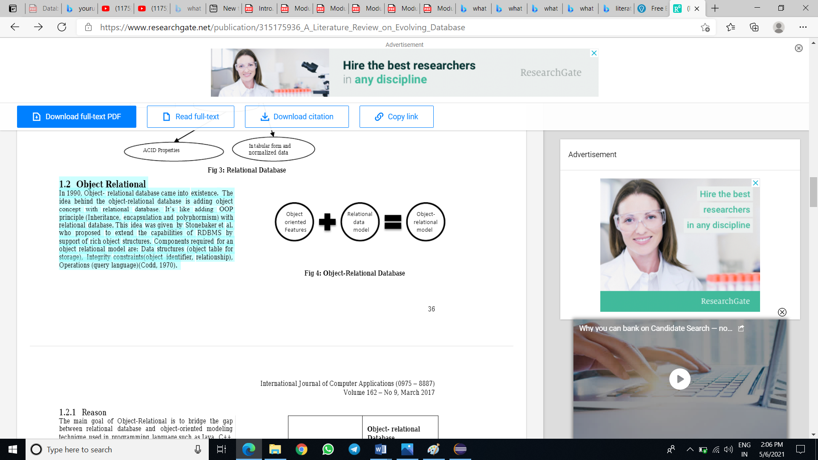

**1.3 Object- Oriented** After 1990, OODBMS came into existence. Concept behind OODBMS is the combination of object oriented programming principle and database management concept. It basic feature is to access object in the database. It supports features like encapsulation, complex object, types and classes, extensibility, persistence etc. Instead of records like E-R model, data is represented in form of classes and objects in OODBMS. Objects are run time entities which have importance in real world problem. All values which are stored in an object are in the form of instance variable. A collection of same type of objects having same type of values and method is called classes. Class is a user-defined data type. Two objects can interact with each other by invoking the method of other objects. Method and data are not visible outside the object and therefore Object oriented Data model provide data abstraction (Kshitij et al., 2001).It is considered to be fifth generation database.

**1.4 Multi-Dimensional Database** Multidimensional structures are used in this data model to organize data and represent relation between stored data. These structures are represented through broken cubes and these cubes are used to store data and user access data from these cubes. These databases use online analytical processing application. Star Schema and snowflake schema are used to represent relational implementation of multidimensional data model. Idea behind this data model was as relational model represent itself in rows and column in table form, like same multi-dimensional data base can be created as cube with many dimensions.

**1.5.NoSQL Database** After last 40 years, variation in relational model has been seen. Many researches has been done with the thought to extend capability of relational database by adding and making variations in it. But this data model was not

**Pg-5**

in tabular form. Name of this model is NOSQL termed as Not only SQL. Scientists were working for this model from 19’s but it came into power in 21st century. This model gave us new more idea and flexibility for data storage. It mainly include four data model : Key-value stores, Document , Graph and column oriented.

**1.6.NewSQL Database** NewSQL is also a new term in database that works on relational model and provide scalability performance same as NOSQL.

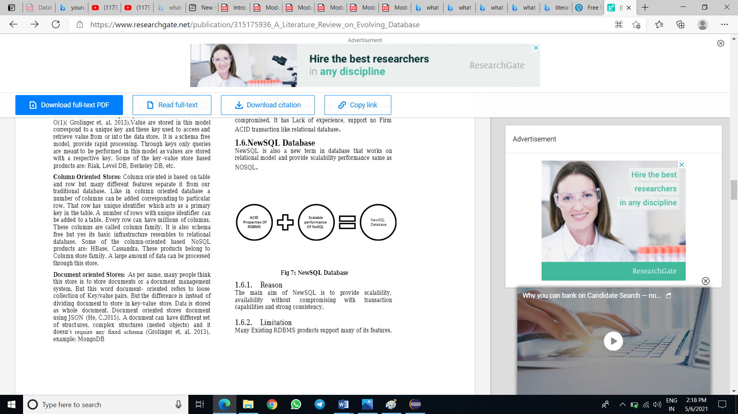

**CONCLUSION**

This survey represents the variation in data model since 90’s to current century. It also represent that researchers always thought to add something to relational database and gave new model for betterment. Due to this relational model was working with us from last many years but NoSQL gave us new direction and provide new way to organize, retrieve data. This all shows that relational model is old enough to trust and to work with, as many number of experiments has already been done with it. Like same NoSQL is under development and adding new features to extend it capability will make users more understand that what next generation requirement is, after this. Polygot persistence is another new technology in the way of database generation after NewSQL and NoSQL.

**Pg-6**

**CHAPTER – 3:**

**PROBLEM STATEMENT & DISCUSSION**

**3.1 Aim:** To create a movie Database Management System

**3.2 Description:** Each movie is identified by title or id. Each movie can have one director and actors appear in it. Actors are identified by actor id and can appear in one or more movies.

Each actor has a role in a movie. Directors are identified by director id and can direct one movie.

Movies can have different attributes like movie release year, movie language, movie rating and should have a movie title.

Similarly directors can have director name, director id and phone number for personal use. For Actors the name, id and gender must be mentioned.

Now the task is to create a database management system for storing the information related to movies for future use or backup purposes. It might be a single user or a multi user application. The software must be made implemented using Java and Sql i.e Structured Query Language.

**Pg-7**

**CHAPTER – 4:**

**PROPOSED SOLUTION & RESULT ANALYSIS**

**Requirements:**

* Eclipse/Netbeans IDE or Notepad
* Mysql or Sql database server

**Solution Description:**

**Architecture**: The Movie Database Application has only two parts, the database and Java application. MySQL is the Database Management System used for the Movie database. All of the data is stored in a single database “movies”. In the “movies” database there are a series of tables such as “movies”, “actors”, “directors”, “movie cast” and “rating” where information related to the movies is stored. Java + JDBC is used to query the database and build the GUI. At first we made a totally console base application. Then after finishing it we wrote a conn.java, Main.java class as well as a bunch of object classes such as Movie.java and Actor.java which turn the relational data (data queried from the database) into objects that the front end can then iterate through and display in lists.The console based program was made using only basic java and sql queries. The GUI was built using Java Swing making it cross platform and easy use with JDBC.

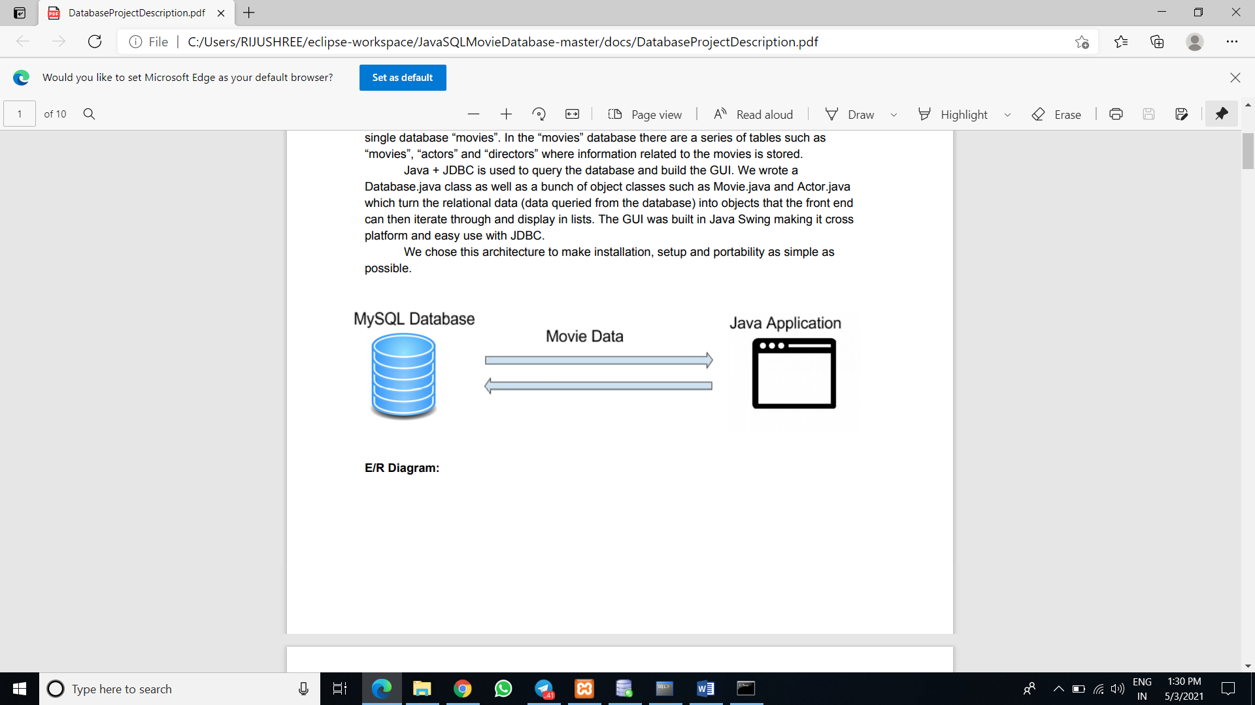

**Pg-8**

**E-R DIAGRAM**

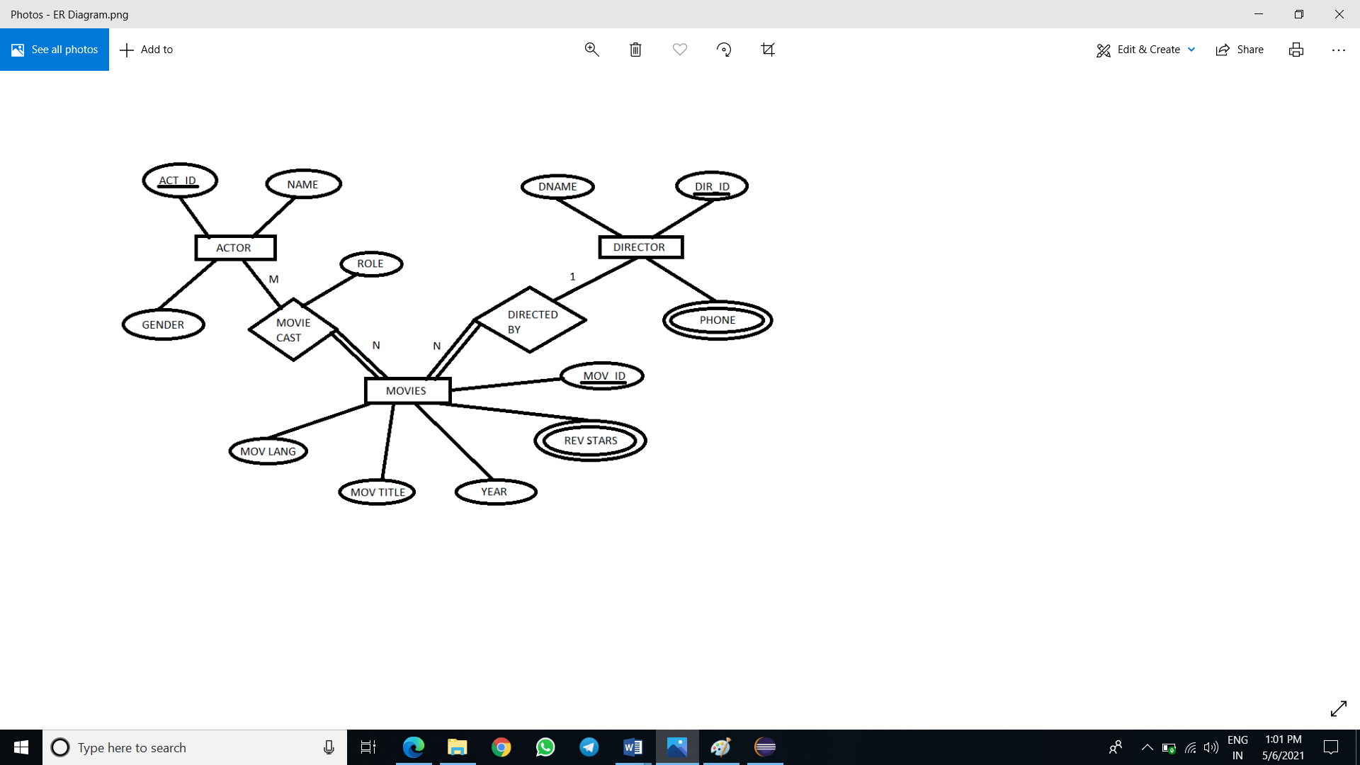

So the above diagram depicts that N movies can have M number of movie cast and 1 director. Actor id, director id, movie id are the primary keys of each of the entities. Movie ratings and director phone numbers can have multiple values.

User can insert, delete or update the rows of any table but the constraints should be kept in mind. Rows of table having foreign keys of other tables attached to it cannot be deleted easily. For that we need to modify the child table contents first.

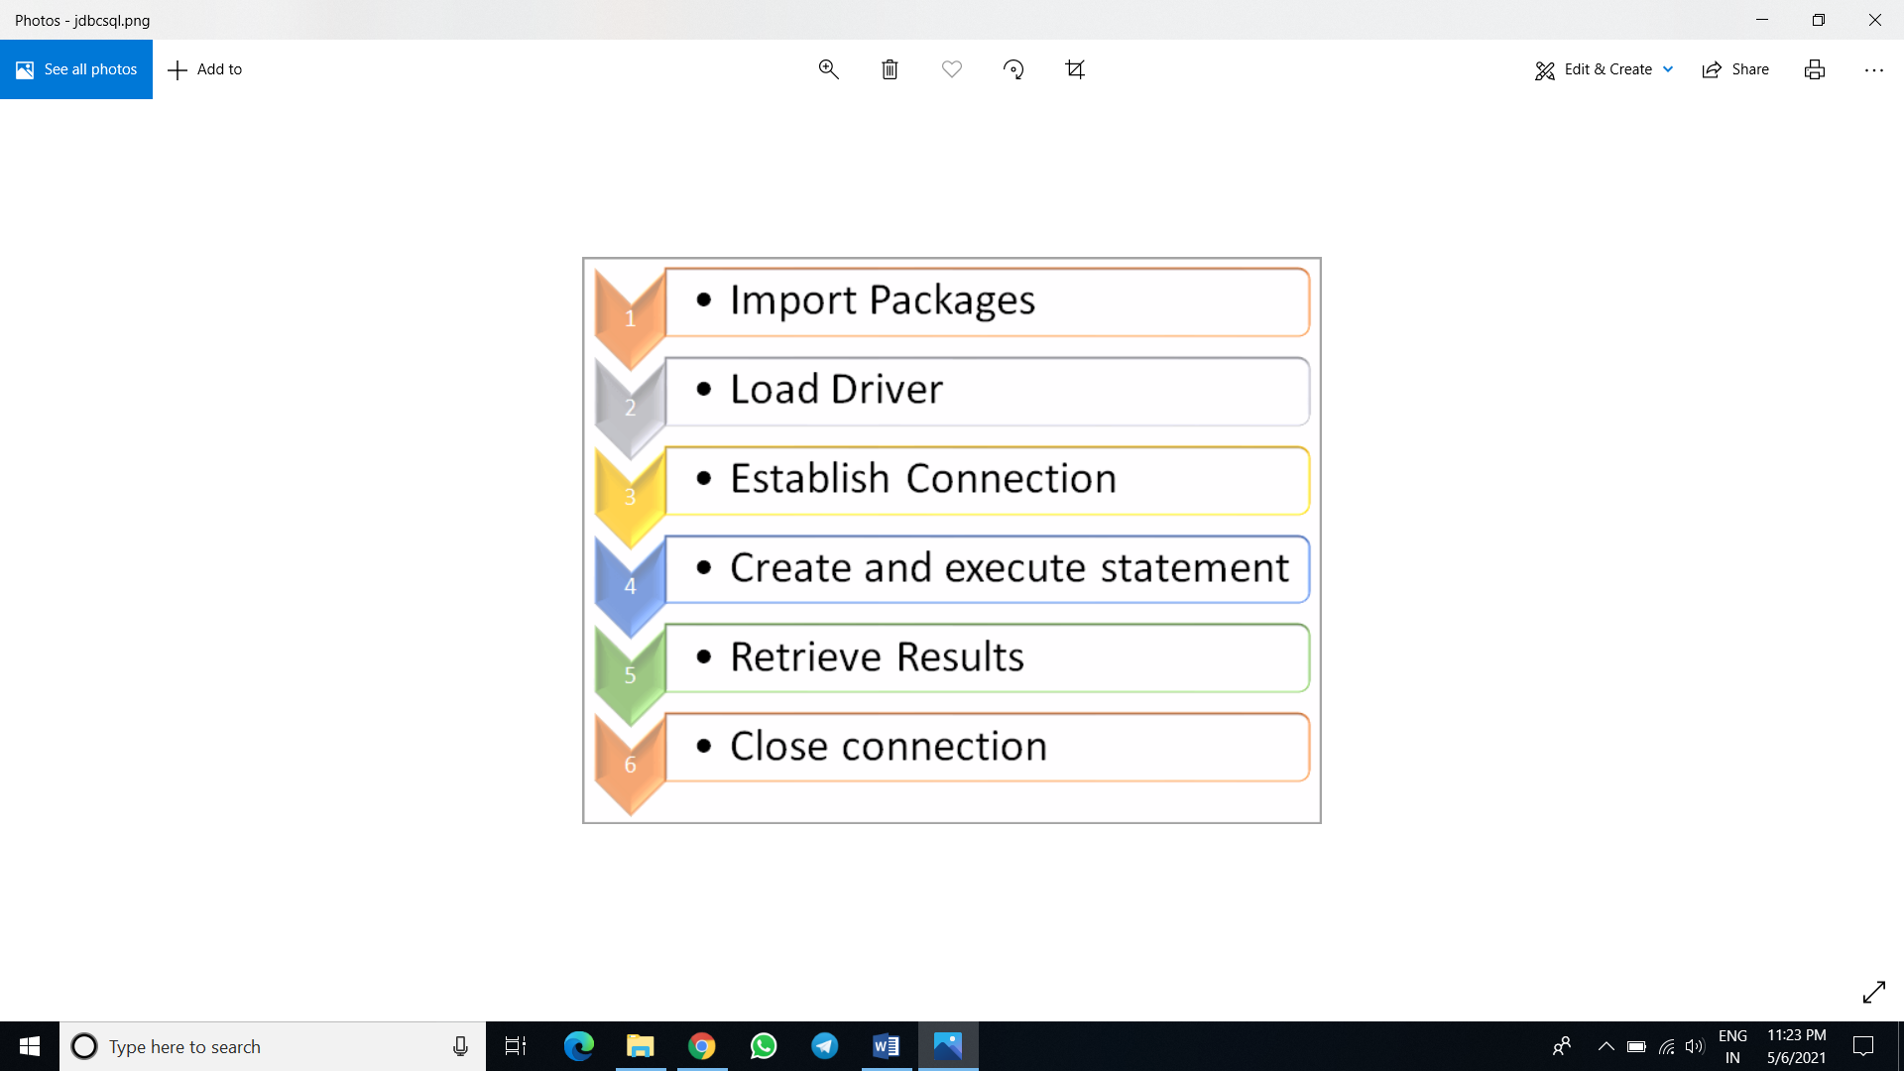

**This is how the process works.**

**Pg-9**

**Below are the snapshots of the Movies Database Management Application GUI.**

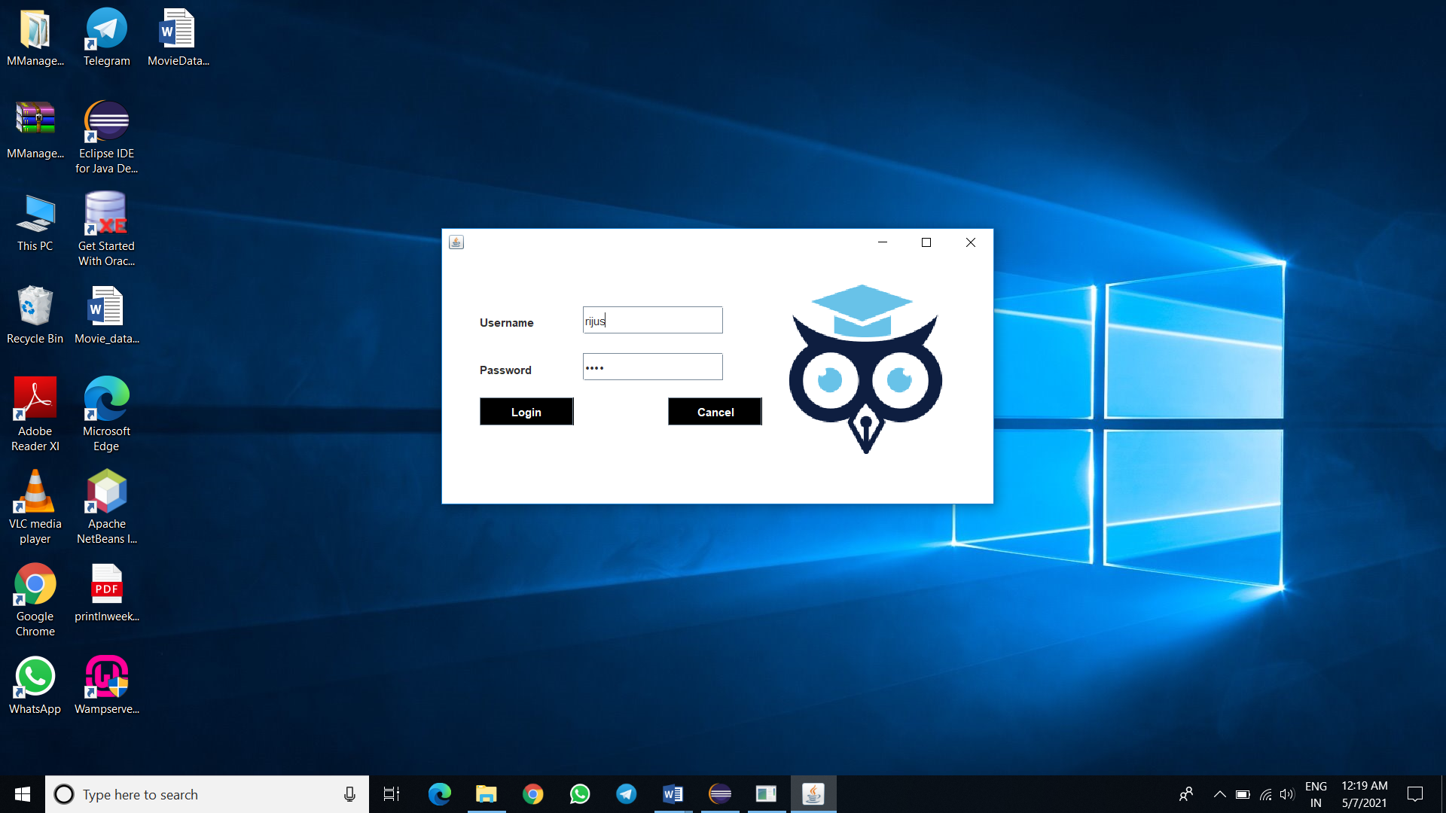

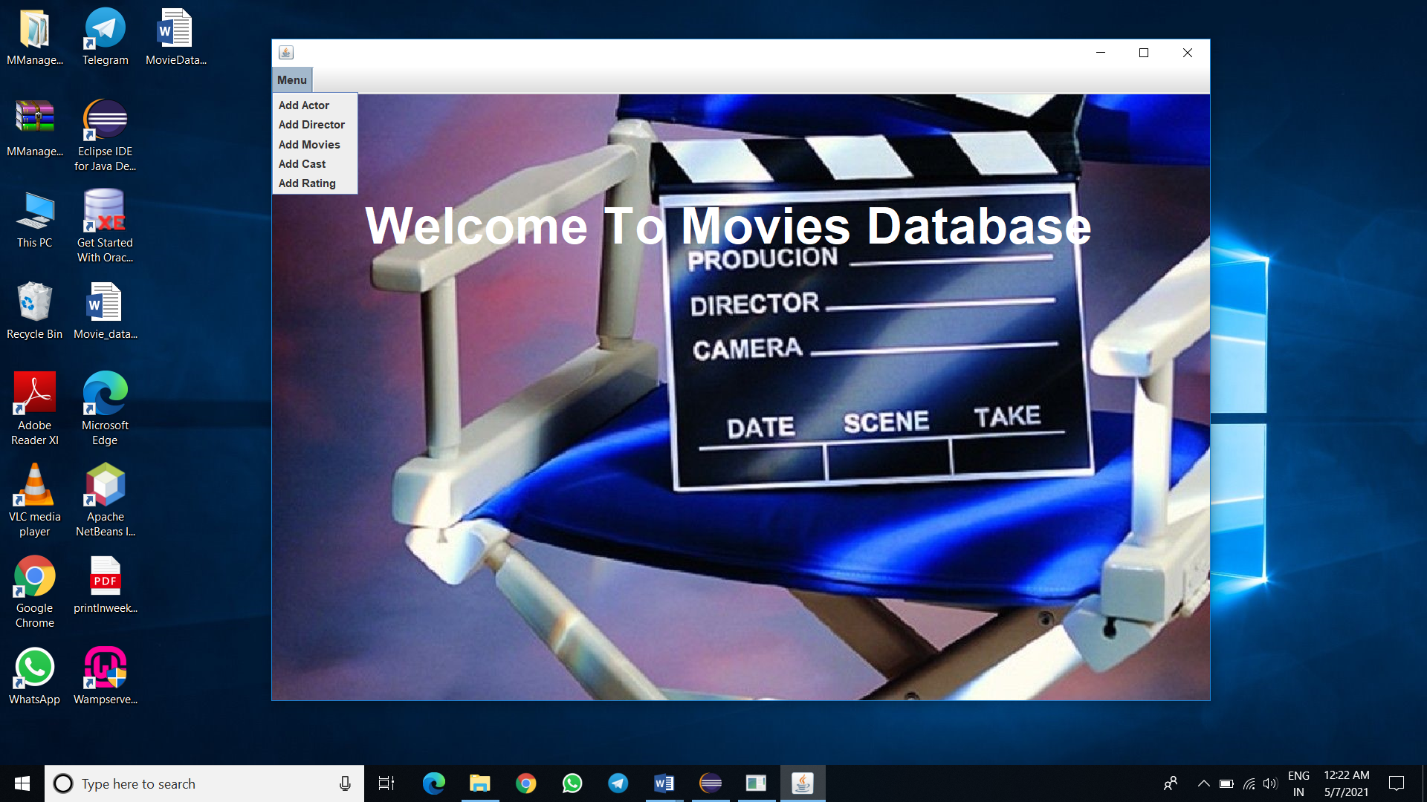

**Pg-10**

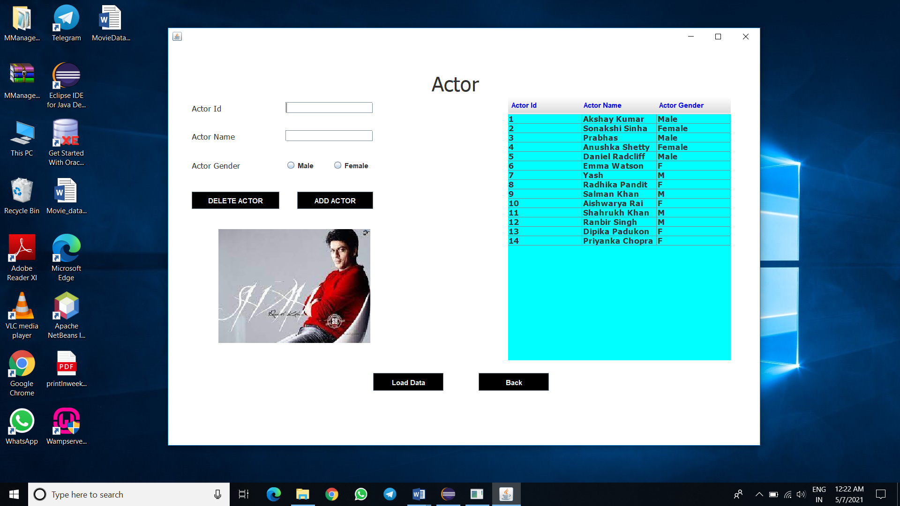

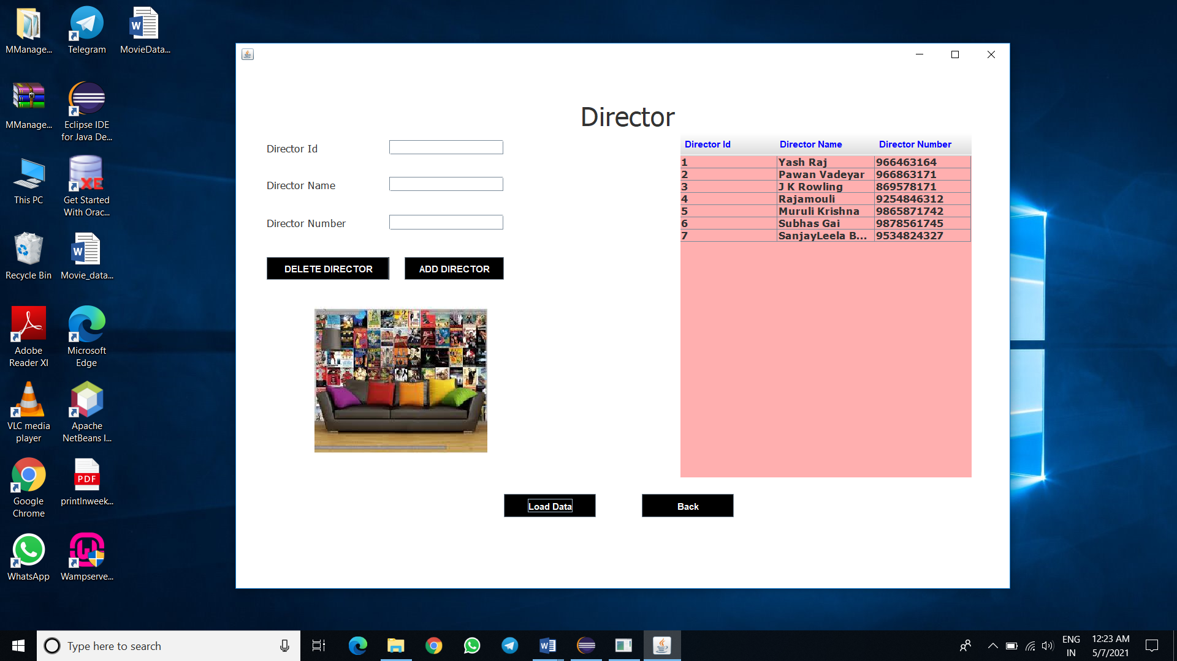

**Pg-11**

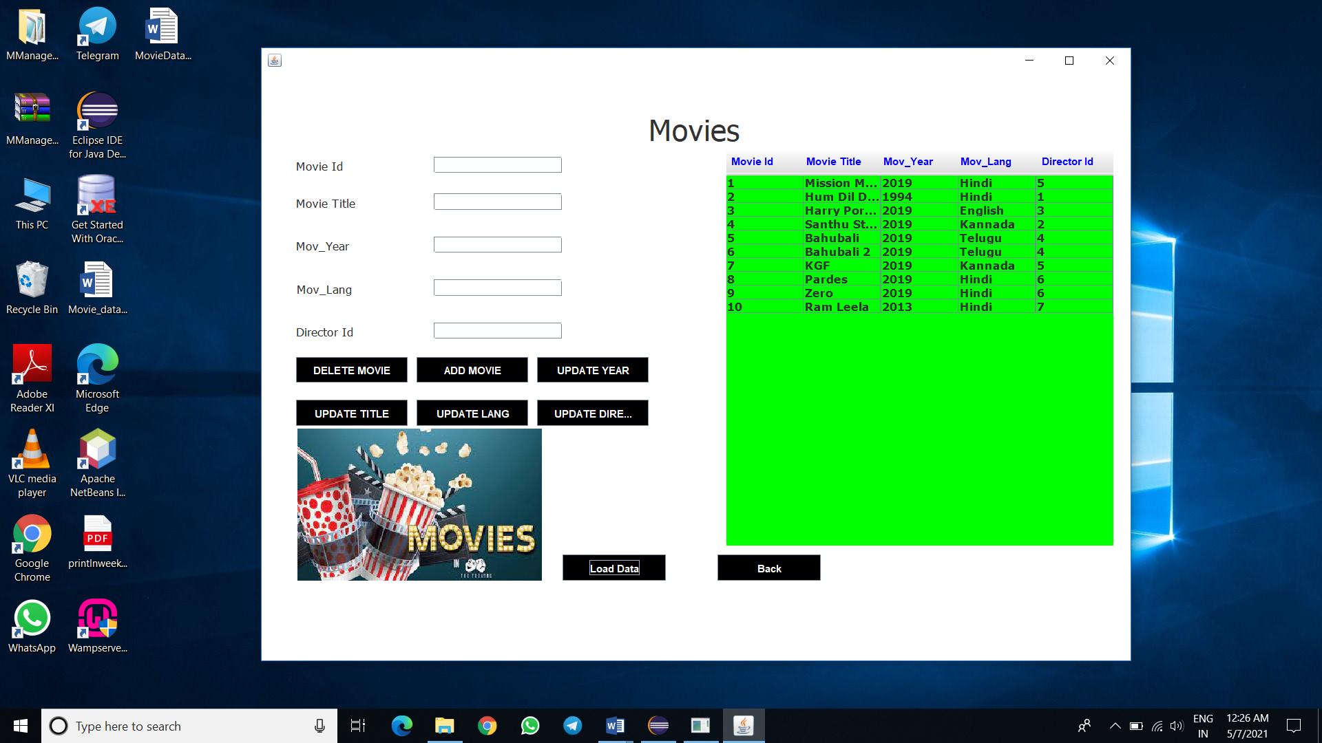

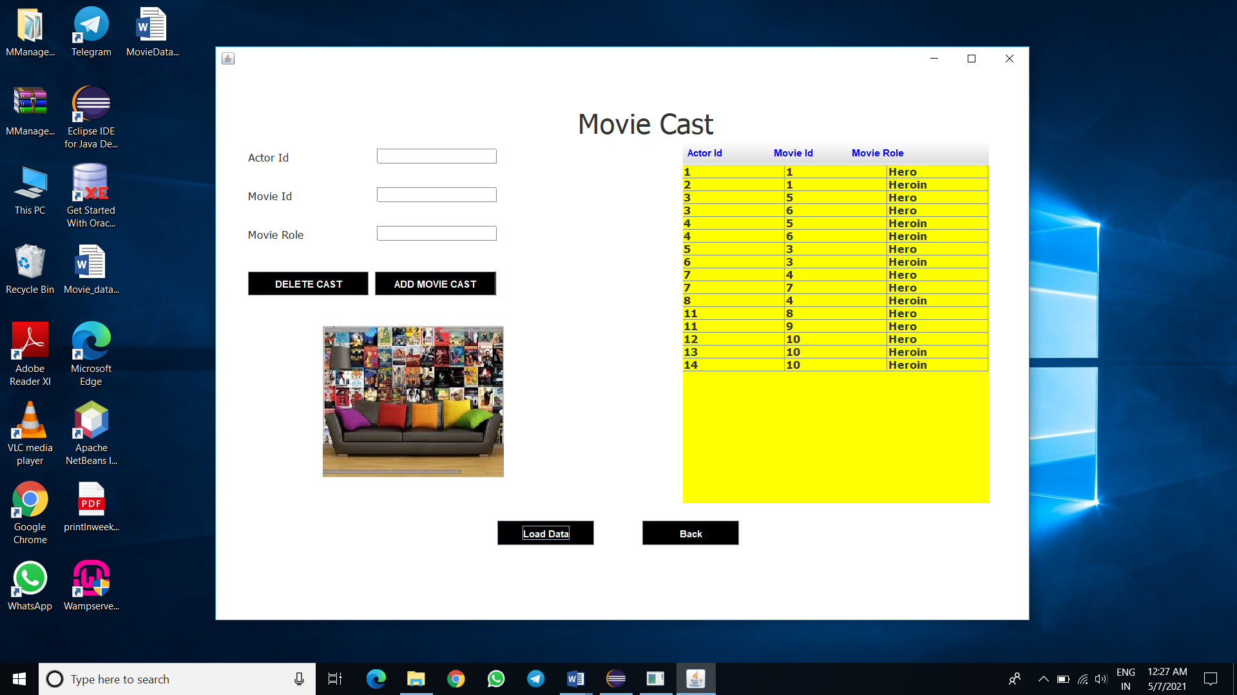

**Pg-12**

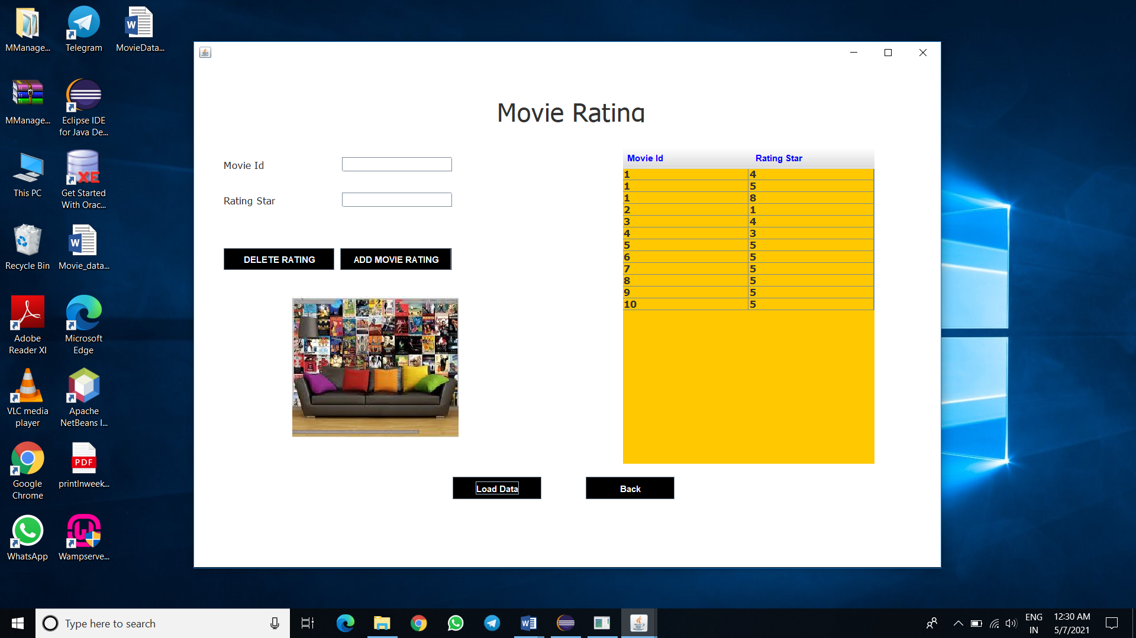

**View of Console Based Project**

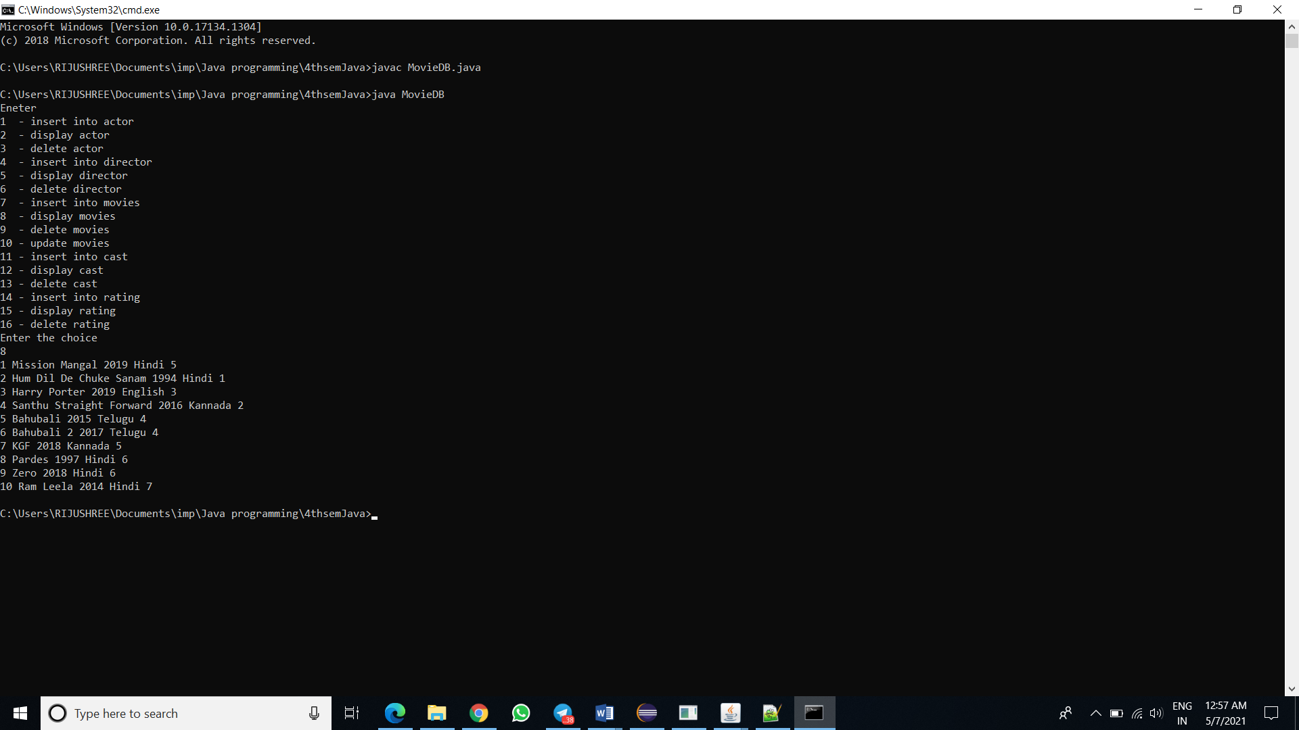

**Pg-13**

**CHAPTER – 5:**

**CONCLUSION & FUTURE SCOPE**

At the end of this project I can surely say that in future we can develop an actual industry level software for storing required movie related details and information. Apart from movies we can use it to store different kinds of information as preferred.

Although we have made a completely console based application and also an application with not so good GUI, it gives a general idea of how a database and a java application works. From the E-R diagram we have learnt how the entities with several attributes relate to each other and depicts the relationships among them.

**Use Case Diagram:** The application is intended to be a general use application for storing information about movies. The application is only intended for one actor, user or director to be able to store relevant movie information and alter it for the purpose of storage. Because of this, the use case diagram is really simple since only one actor uses the software/database**.**

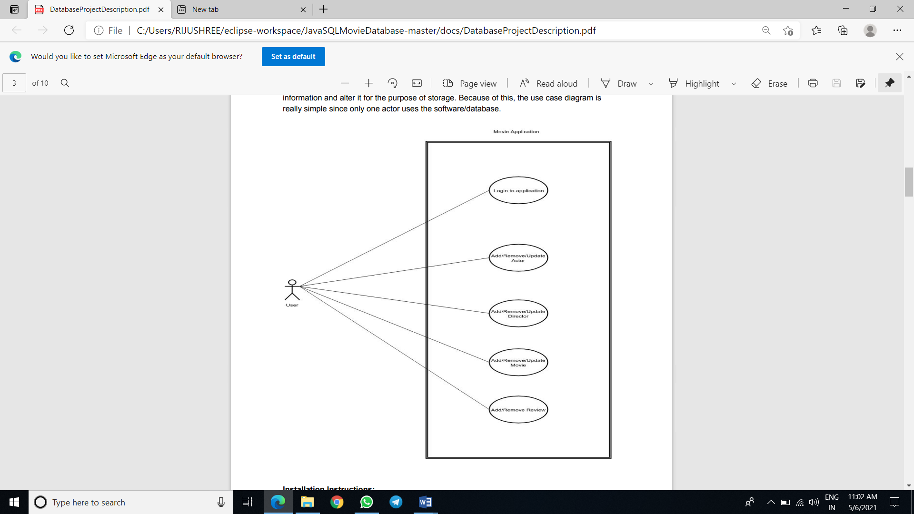

**Pg-14**

**CHAPTER – 6:**

**BIBLIOGRAPHY**

**I have taken help from some sql youtube videos and websites .**

**To mention a few-**

**Youtube** :- <https://www.youtube.com/watch?v=v8t0LrPTUGE&t=119s>

**Websites** :- <https://www.w3schools.com/sql/sql_ref_database.asp>

[(PDF) A Literature Review on Evolving Database (researchgate.net)](https://www.researchgate.net/publication/315175936_A_Literature_Review_on_Evolving_Database)